**INTRODUCTION**

* 1. **Project Overview**

The project focuses on developing a robust system for detecting online payment fraud. Utilizing a classification model, you'll be working with a dataset from Kaggle, a platform known for its diverse and challenging datasets. The dataset likely contains a mix of legitimate and fraudulent transactions, providing the necessary input to train and fine-tune your classification model.

The workflow involves pre-processing and exploring the data, selecting relevant features, and training the classification model. Post-training, the model will be integrated into an online payment system to evaluate and predict the legitimacy of transactions in real-time. The ultimate goal is to create an effective and efficient fraud detection system that contributes to the security and trustworthiness of online financial transactions.

* 1. **Purpose**

The primary purpose of this project is to combat the rising threat of online payment fraud. As digital transactions become increasingly prevalent, the need for robust security measures is paramount. The classification model serves as an intelligent filter, learning from historical data to distinguish between genuine and fraudulent transactions.

By implementing this system, you're contributing to the creation of a safer online environment for users and businesses engaged in financial transactions. This proactive approach to fraud detection not only safeguards individuals from potential financial losses but also helps maintain the integrity and credibility of online payment systems. In essence, your project is a crucial step towards fostering trust and confidence in the digital economy.

**LITERATURE SURVEY**

**2.1 Existing problem**

Online payment fraud poses a significant threat to the security and integrity of digital financial transactions. With the increasing reliance on online platforms for payments, the vulnerabilities to various fraudulent activities, such as unauthorized transactions, identity theft, and phishing attacks, have also risen. Traditional security measures are often not sufficient to counter the evolving tactics of fraudsters. Hence, there is a pressing need for advanced and adaptive systems that can effectively identify and prevent online payment fraud.

**2.2 Problem Statement Definition**

The project aims to address the existing problem of online payment fraud by developing a robust fraud detection system using a classification model trained on a Kaggle dataset. The specific objectives include:

* Pre-processing and exploring the Kaggle dataset to understand the characteristics of legitimate and fraudulent transactions.
* Selecting relevant features and training a classification model capable of distinguishing between legitimate and fraudulent transactions.
* Integrating the trained model into an online payment system to analyze incoming transactions in real-time.
* Implementing an alert or prevention mechanism to flag or block potentially fraudulent transactions.

The success of the project will be measured by the accuracy and efficiency of the developed system in detecting and preventing online payment fraud, contributing to the overall security of digital financial transactions. This problem statement sets the foundation for creating a proactive and adaptive solution to the challenges posed by online payment fraud.

**IDEATION AND PROPOSED SOLUTION**

**3.1 Empathy Map Canvas**

An empathy map is a straightforward and visually intuitive representation that compiles information about a user's actions and mindset. This tool serves as a valuable resource for teams seeking to gain deeper insights into their users. To devise a successful solution, it is

crucial to grasp the actual issue at hand and gain a comprehensive understanding of the individual undergoing it. The process of constructing this map encourages participants to view matters through the user's lens, taking into account their objectives and obstacles.

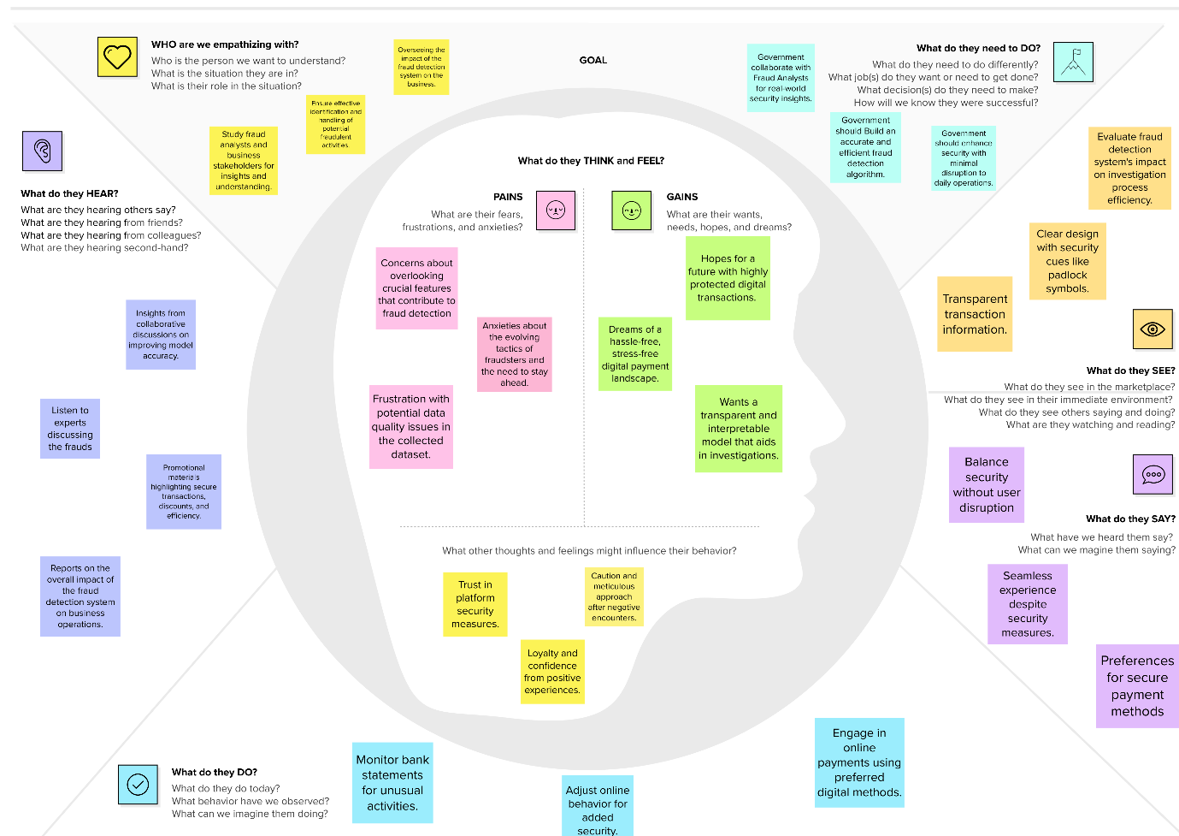

**3.2 Ideation & Brainstorming**

Brainstorming cultivates a liberated and inclusive atmosphere where all team members are

prompted to engage in the creative thinking process essential for problem-solving. Emphasizing quantity of ideas over their immediate worth, unconventional suggestions are embraced and refined. The collaborative spirit among participants is actively promoted, facilitating the generation of a diverse array of innovative solutions. Utilize this framework in your own brainstorming sessions to empower your team in unleashing their creative potential and shaping ideas, even when they are not physically present in the same space.



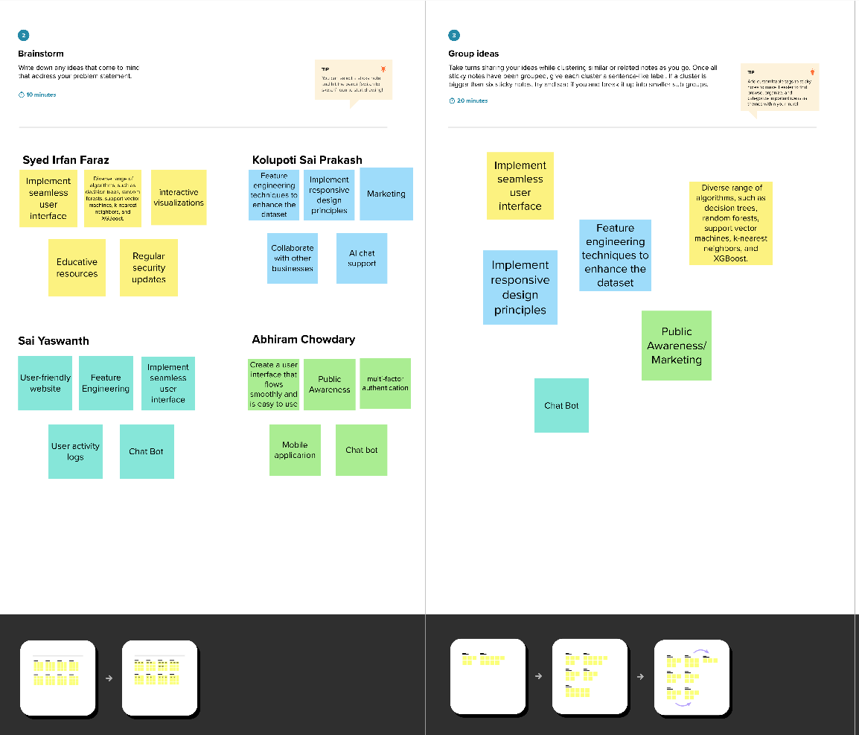

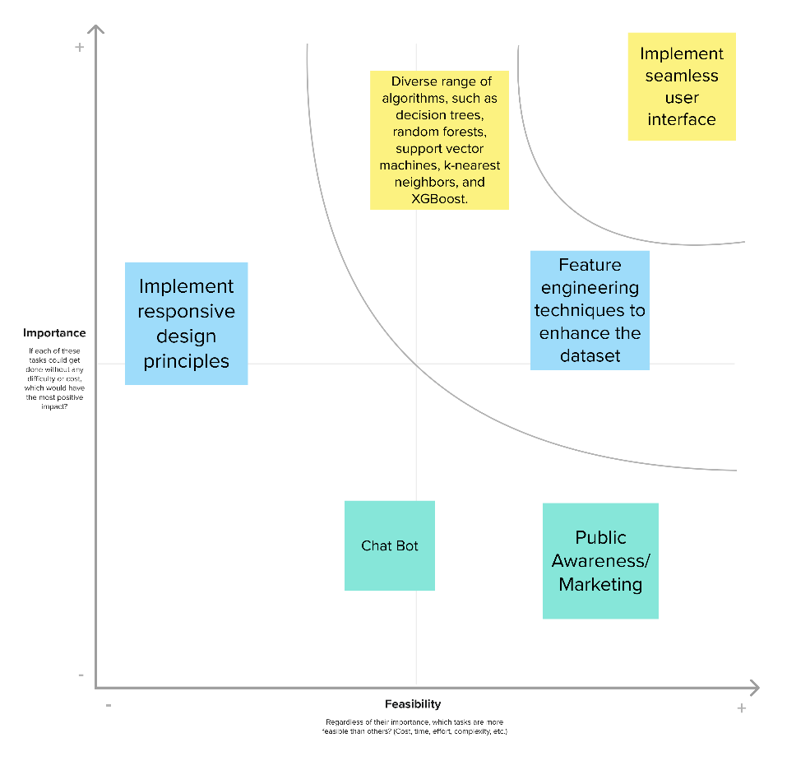

**REQUIREMENTS ANALYSIS**

**4.1 Functional Requirements**

Functional requirements outline the specific features and capabilities that the system must possess to fulfil its intended purpose. For the online payment fraud detection project, these may include:

Data Pre-processing:

The system should be capable of cleaning and Pre-processing the Kaggle dataset to handle missing values, outliers, and irrelevant features.

Feature Selection:

Identification and selection of relevant features that contribute to the accurate classification of legitimate and fraudulent transactions.

Model Training:

Implementation of a classification model (e.g., machine learning algorithm) for training on the pre-processed dataset to learn patterns associated with fraud.

**4.2 Non – Functional Requirements**

Non-functional requirements define the qualities that the system must have, such as performance, security, and usability. For the online payment fraud detection project, these may include:

Performance:

The system should be able to process transactions in real-time with minimal latency.

Accuracy:

The classification model should achieve a high level of accuracy in distinguishing between legitimate and fraudulent transactions.

Scalability:

The system should be scalable to handle an increasing volume of transactions as the user base grows.

Security:

Ensuring the confidentiality and integrity of the data, particularly sensitive information related to transactions and user details.

Reliability:

The system should be reliable, minimizing false positives and false negatives in fraud detection.

Usability:

The user interface should be intuitive and user-friendly, allowing system administrators to easily navigate and manage the fraud detection system.

Maintainability:

The system should be designed for easy maintenance, allowing updates to the model or system without significant downtime.

Compliance:

Adherence to relevant legal and regulatory standards, such as data protection and privacy laws.

These functional and non-functional requirements provide a comprehensive framework for the development and evaluation of the online payment fraud detection system.

**PROJECT DESIGN**

**5.1 Data Flow Diagrams & Solution Architecture**

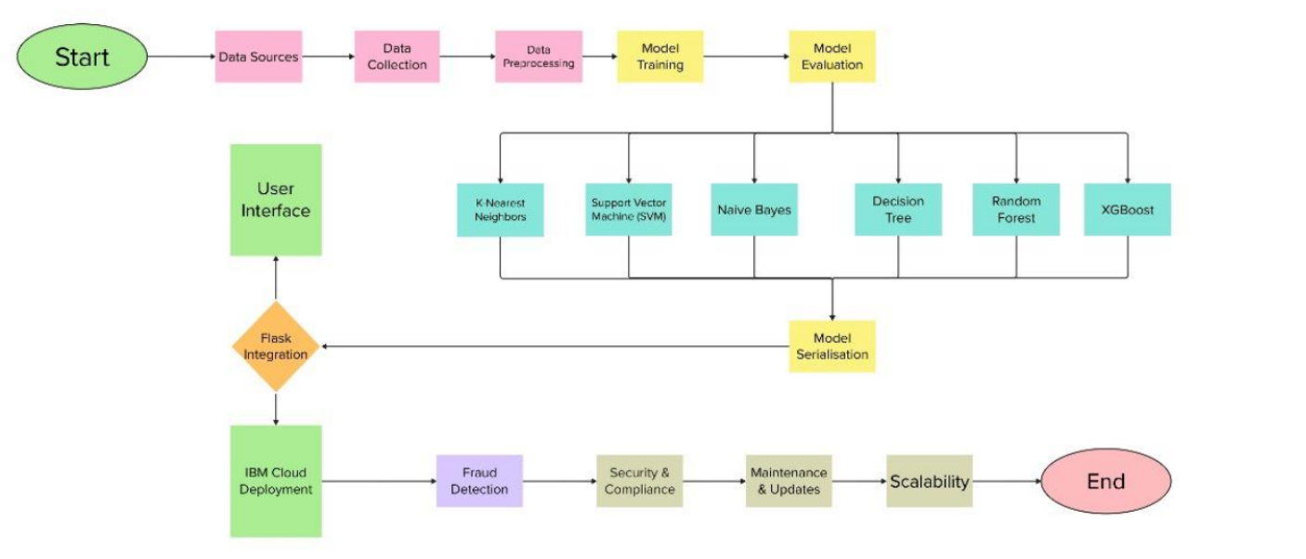

Solution architecture is a complex process – with many sub-processes – that bridges the gap between business problems and technology solutions. Its goals are to:

• Find the best tech solution to solve existing business problems.

• Describe the structure, characteristics, behavior, and other aspects of the software to project stakeholders.

• Define features, development phases, and solution requirements.

• Provide specifications according to which the solution is defined, managed, and delivered.

**PROJECT PLANNING & SCHEDULING**

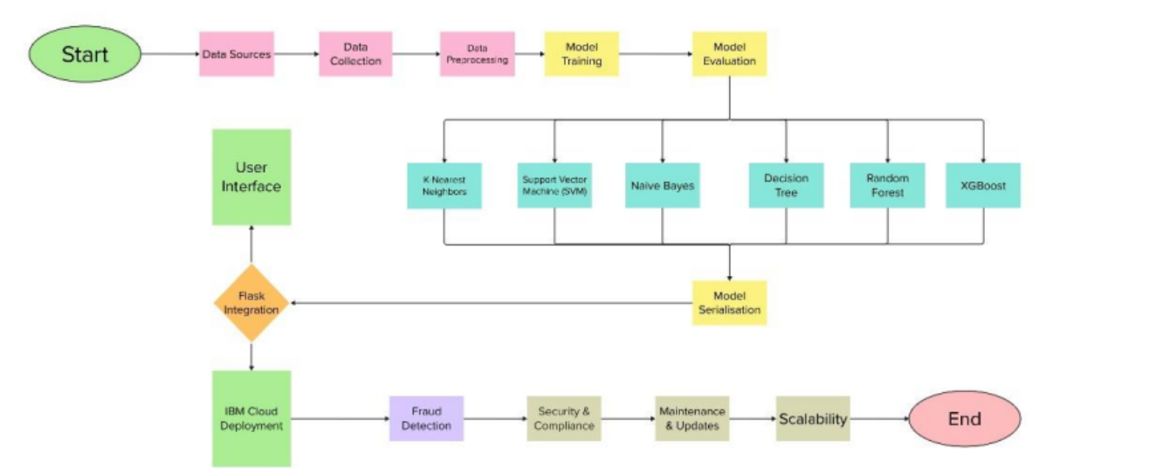**6.1 Technical Architecture**

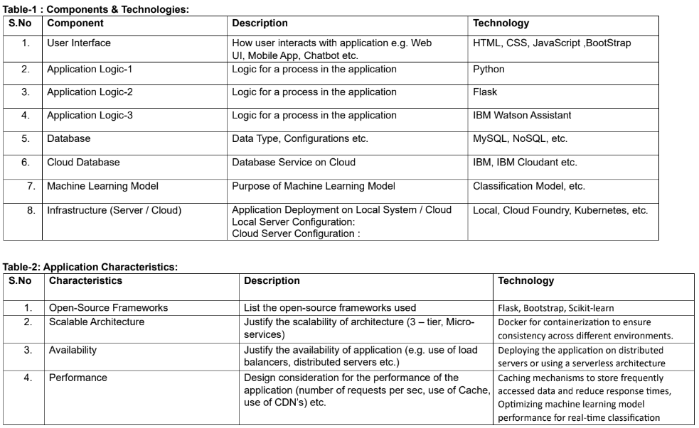

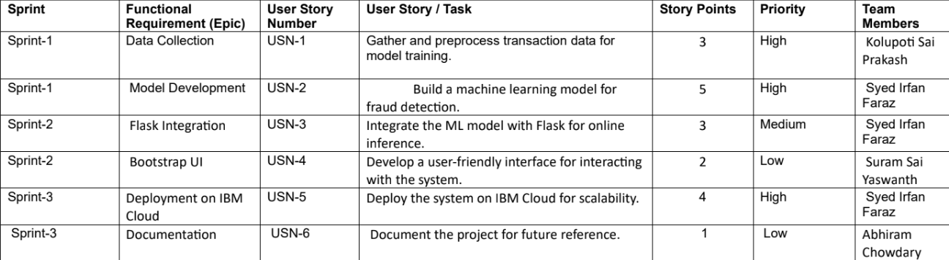**6.2 Sprint Planning & Estimation**

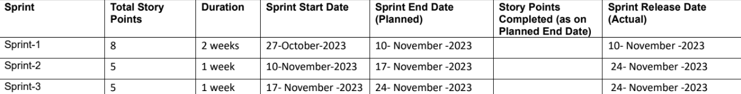

**CODING AND SOLUTION**

# Project Structure:

Create the Project folder which contains files as shown below

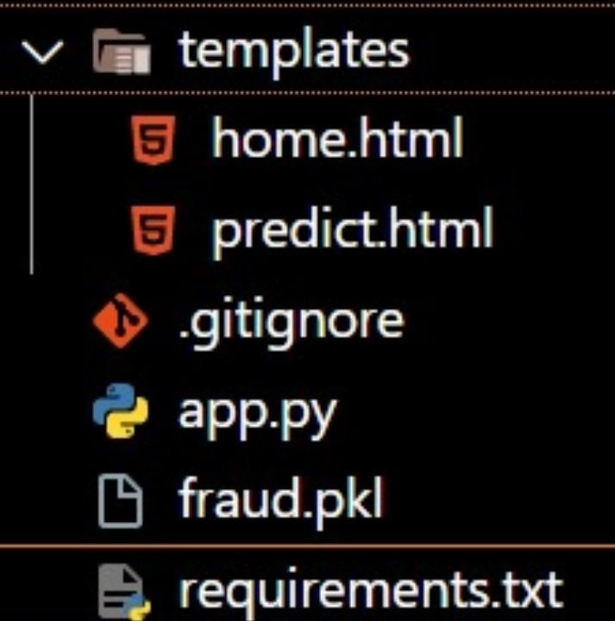

* We are building a flask application which needs HTML pages stored in the templates folder and a python script app.py for scripting.
* Model.pkl is our saved model. Further we will use this model for flask integration.
* Training folder contains model training files and the training_ibm folder contains IBM deployment files.

# Milestone 1: Data Collection

Machine learning relies extensively on data, constituting a pivotal factor that enables the training of algorithms. This section provides the opportunity to download the necessary dataset, a critical step in facilitating the training process for algorithms.

# Collect the dataset or create the dataset or Download the dataset:

Various widely used open platforms are available for data collection, such as Kaggle.com and the UCI repository. In our project, we specifically employed the dataset named PS_20174392719_1491204439457_logs.csv, obtained through a download from Kaggle.com. To access and download the dataset, please consult the provided link below.

Link: <https://www.kaggle.com/datasets/rupakroy/online-payments-fraud-detection-dataset>

# Milestone 2: Visualising and analysing data

Now that the dataset has been obtained, let's read and grasp the data effectively, employing

visualization techniques and analysis methods. This will deepen our understanding of the dataset, offering valuable insights for additional exploration.

# Note: There are a number of techniques for understanding the data. But here we have used some of it. In an additional way, you can use multiple techniques.

**Activity 1: Importing the libraries**

Import the necessary libraries as shown in the image. (optional) Here we have used visualisation style as fivethirtyeight.

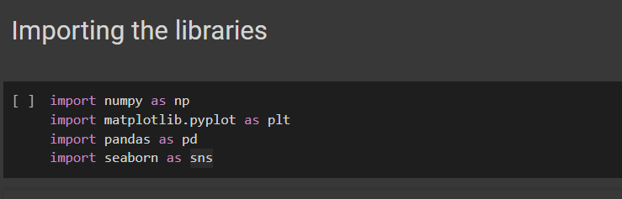

# Activity 2: Read the Dataset

The dataset may come in various formats like .csv, Excel, .txt, .json, etc., and Pandas offers the

`read_csv()` function for CSV files, requiring the file path as a parameter. Equivalent functions like

`read_excel()`, `read_table()`, or `read_json()` can be used for other formats, providing a flexible solution for data loading and manipulation in Pandas.

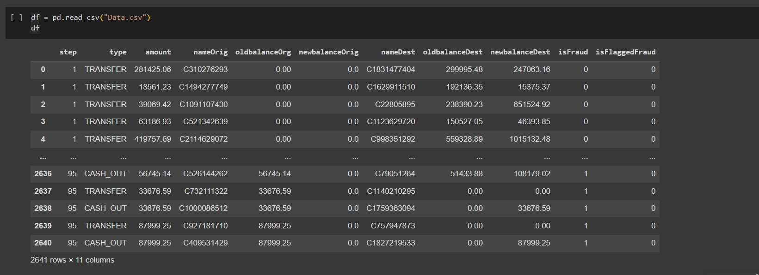

The `df.info()` code provides a concise summary of the DataFrame `df`. It displays essential information such as the data types, non-null counts, and memory usage. This is valuable for a quick overview of the dataset's structure and characteristics.

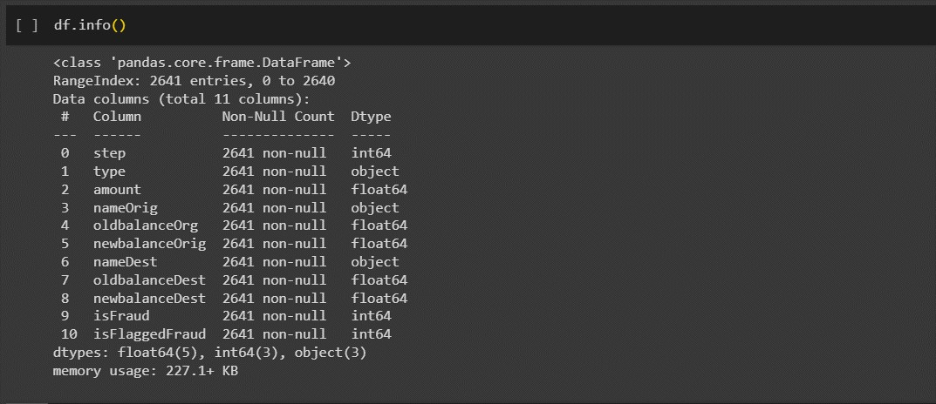

The code `df['isFraud'].value_counts()` counts the occurrences of unique values in the 'isFraud' column of the DataFrame `df`. It is useful for understanding the distribution of fraud and non-fraud instances in the dataset.

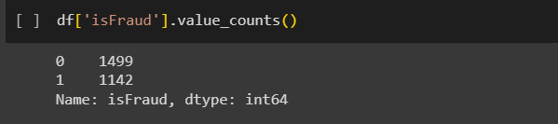

The code `df.describe()` generates descriptive statistics of the numerical columns in the DataFrame `df`. It provides key statistical measures, including count, mean, standard deviation, minimum, and maximum values, offering a quick insight into the central tendency and spread of the data.

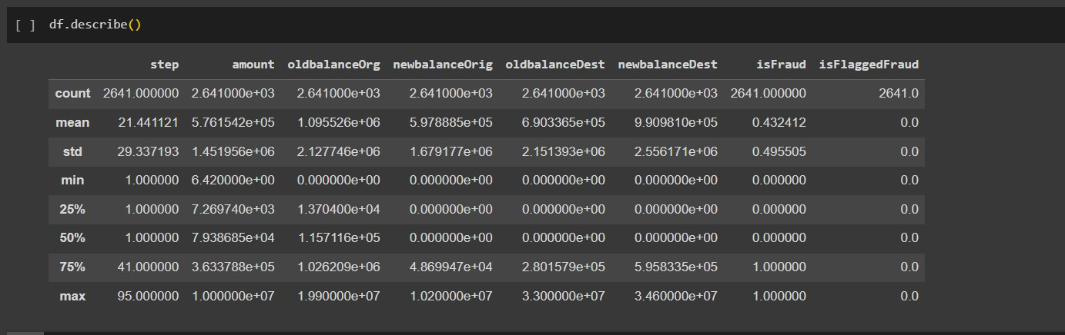

The code `df = df.dropna()` removes rows with missing values from the DataFrame `df`. This operation is useful for ensuring data integrity and preparing the dataset for analysis by eliminating instances with

incomplete information.

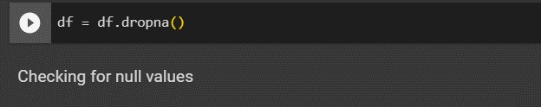

The code `df.isnull().sum()` calculates the count of missing values for each column in the DataFrame `df`. It provides a summary of the data's completeness, indicating how many null values exist in each column.

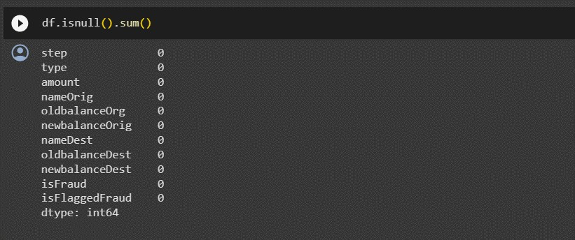

# Data Visualization:

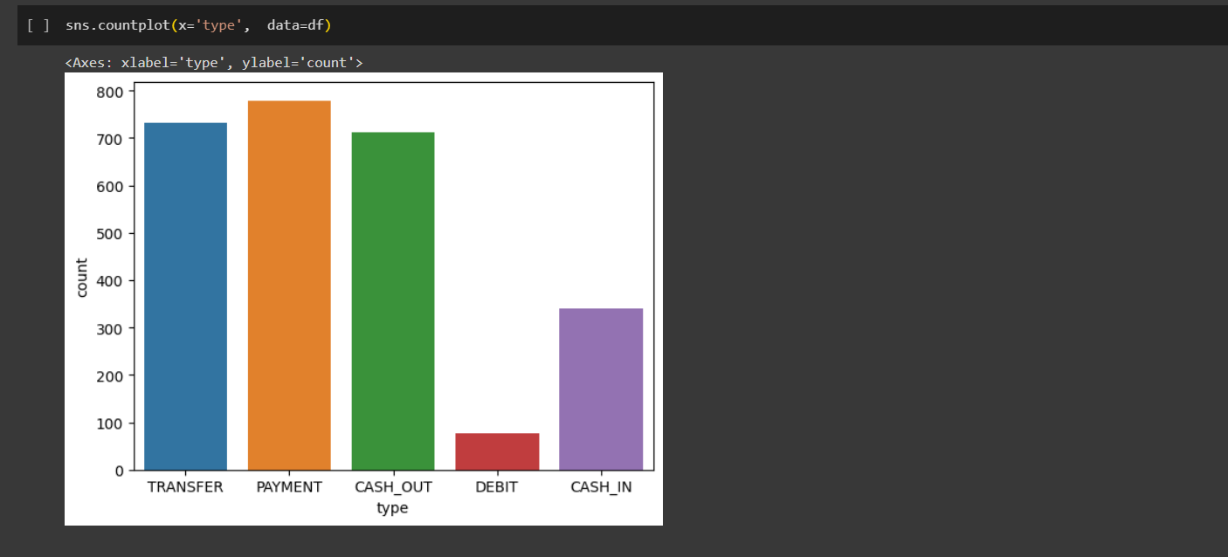The code `sns.countplot(x='type', data=df)` uses the Seaborn library to create a count plot based on the 'type' column in the DataFrame `df`. This visualization depicts the distribution of categories in the 'type' column, offering insights into the frequency of each category.

# Retain 6 features and target variable:

The code `df = df[['amount', 'oldbalanceOrg', 'newbalanceOrig', 'oldbalanceDest', 'newbalanceDest', 'isFraud']]` selects specific columns ('amount', 'oldbalanceOrg', 'newbalanceOrig', 'oldbalanceDest',

'newbalanceDest', and 'isFraud') from the DataFrame `df`. This operation creates a new DataFrame with only the chosen columns, focusing on relevant features for further analysis or modeling.



The provided code categorizes the columns in the DataFrame `df` based on their data types. It identifies and lists categorical variables, integer variables, and float variables separately. The output indicates the count of each variable type, providing a quick summary of the data's composition.

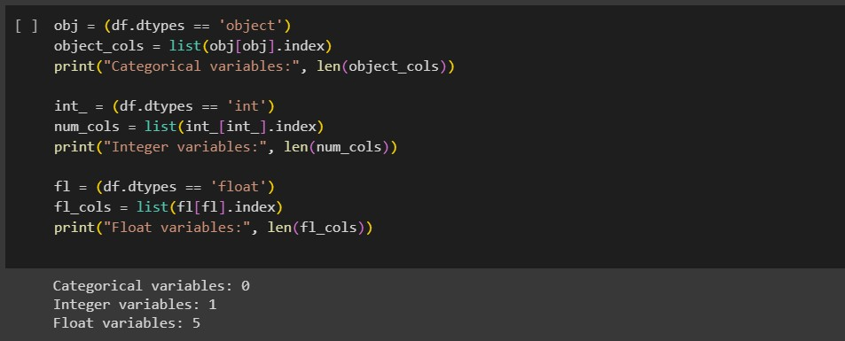

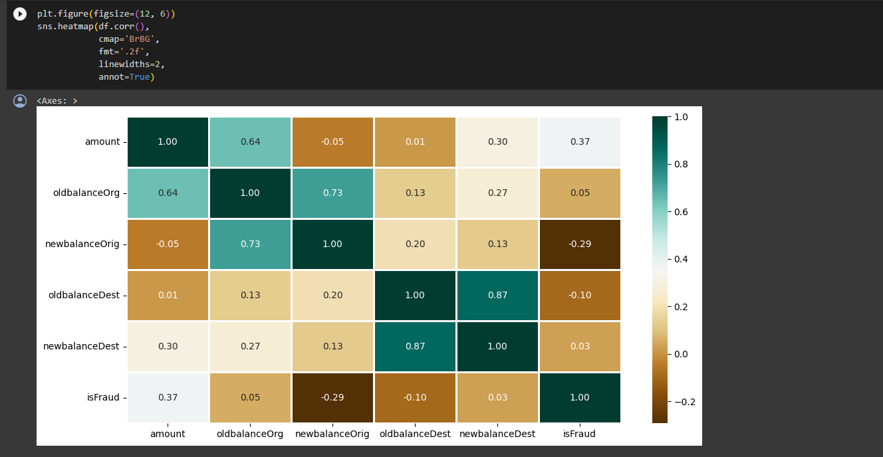The code uses Matplotlib and Seaborn libraries to create a heatmap of the correlation matrix for the DataFrame `df`. The figure size is set to 12 by 6 inches. The heatmap visualizes the pairwise correlations between numerical columns, with values annotated on the plot. It helps identify relationships between variables, with color intensity indicating the strength and direction of correlation. The 'BrBG' colormap is applied, and the format is set to display correlation values with two decimal places.

# Handling outliers

The code `sns.boxplot(df["amount"])` utilizes Seaborn to create a boxplot for the 'amount' column in the DataFrame `df`. This visualization offers insights into the distribution of the 'amount' variable, displaying key statistical measures such as the median, quartiles, and potential outliers.

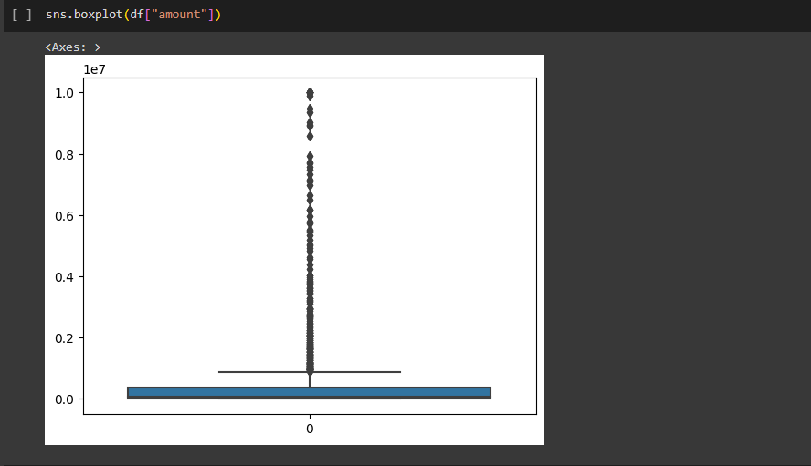

The code utilizes the SciPy library to calculate the mode of the 'amount' column in the DataFrame `df` using `stats.mode()`. Additionally, it computes the mean of the 'amount' column using NumPy's

`np.mean()`. These statistical measures provide insights into the central tendency of the 'amount' variable, with the mode representing the most frequently occurring value and the mean indicating the average value.

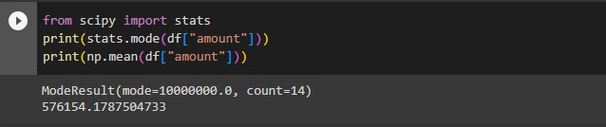

The code calculates the interquartile range (IQR) for the 'amount' column in the DataFrame `df` and defines upper and lower bounds to identify potential outliers. It prints the values of the first quartile (q1), third quartile (q3), IQR, upper bound, and lower bound. The code then counts the number of data points beyond the upper and lower bounds, indicating potential skewed data points. This analysis helps identify and understand the distribution of the 'amount' variable in terms of outliers.

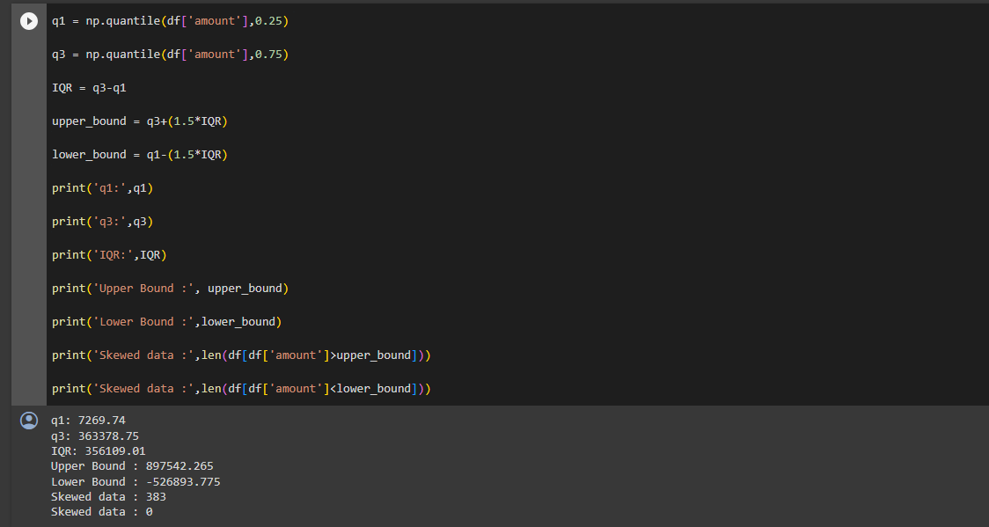

The code defines a function, `transformationPlot(feature)`, which generates a side-by-side plot. The left subplot is a histogram (using Seaborn) representing the distribution of the input feature, while the right subplot is a probability plot (using SciPy's `probplot` from the `stats` module). This function is designed to provide visual insights into the distribution and potential transformation of a given feature.

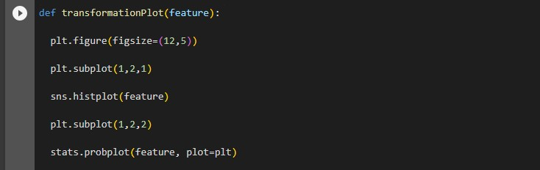

The code applies the `transformationPlot` function to the logarithmically transformed 'amount' column (`np.log(df['amount'])`). This facilitates visualizing the impact of the logarithmic transformation on the distribution of the 'amount' variable, helping assess the effectiveness of this transformation for

normalization or addressing skewness.

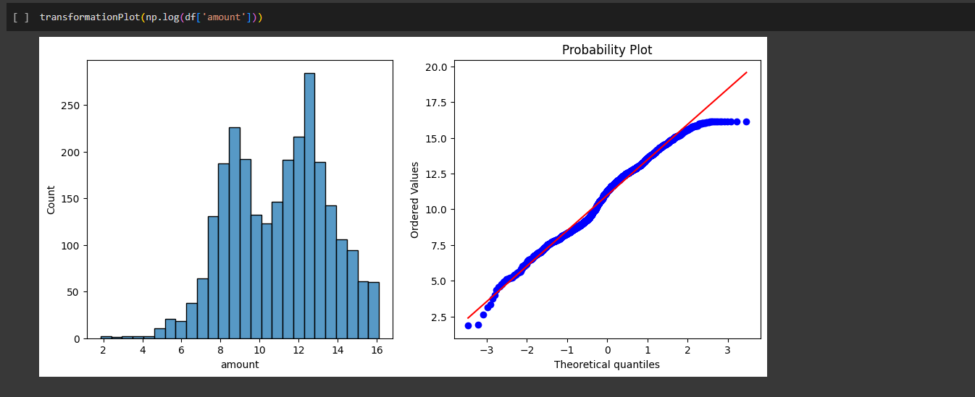

# X and Y split:

The code creates a new DataFrame `X` by dropping the 'isFraud' column from the original DataFrame

`df`. This operation is typically performed to isolate the independent variables, preparing the data for model training where 'isFraud' is the dependent variable.

The code creates a Series `y` by extracting the 'isFraud' column from the DataFrame `df`. This is typically done to define the dependent variable for a machine learning model, separating it from the independent variables stored in the DataFrame `X`.



# Split the data into training and testing:

The code utilizes scikit-learn's `train_test_split` function to split the dataset into training and testing sets. It assigns 70% of the data to the training set (`X_train` and `y_train`) and 30% to the testing set (`X_test` and `y_test`). The parameter `random_state=42` ensures reproducibility of the split. This separation is

essential for training and evaluating machine learning models.

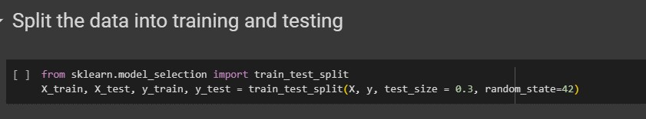

# Model Building and Evaluation Training the Naive Bayes model:

The code uses scikit-learn's `GaussianNB` to instantiate a Gaussian Naive Bayes classifier (`Cnb`). The classifier is then trained on the training sets (`X_train` and `y_train`) using the `fit` method. This

establishes the Naive Bayes model for subsequent predictions based on the training data.

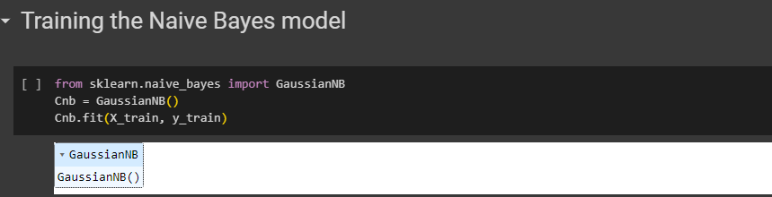

The code utilizes scikit-learn's metrics module to evaluate the performance of a Gaussian Naive Bayes classifier (`Cnb`). It predicts the target variable (`y_pred`) on the test set (`X_test`) using the trained Naive Bayes model. The confusion matrix (`cm`) is calculated by comparing the predicted values to the actual values (`y_test`). Additionally, the accuracy score of the model is computed using the

`accuracy_score` function, offering an overall measure of model performance.

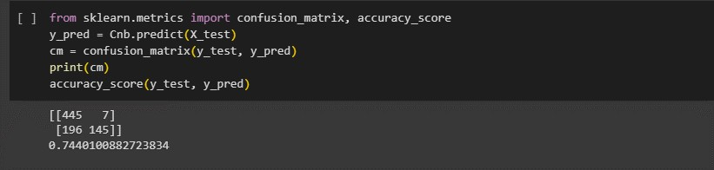

# Applying k-Fold Cross Validation:

The code utilizes scikit-learn's `cross_val_score` to perform 10-fold cross-validation on a Gaussian Naive Bayes classifier (`Cnb`). It calculates accuracy scores for each fold, and the mean accuracy along with thestandard deviation of the accuracy scores is printed. This provides insights into the Naive Bayes model's generalization performance across different subsets of the training data.

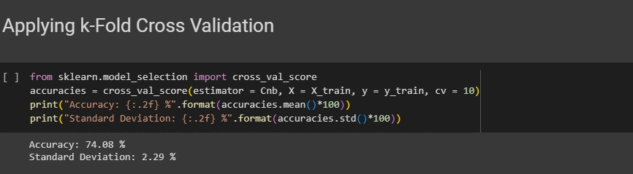

# Training the Decision Tree Classification model:

The code uses scikit-learn's `DecisionTreeClassifier` to instantiate a Decision Tree classifier (`Cdt`). The classifier is configured with the entropy criterion and a specified random state for reproducibility. It is

then trained on the training sets (`X_train` and `y_train`) using the `fit` method, establishing the Decision Tree model for subsequent predictions based on the training data.

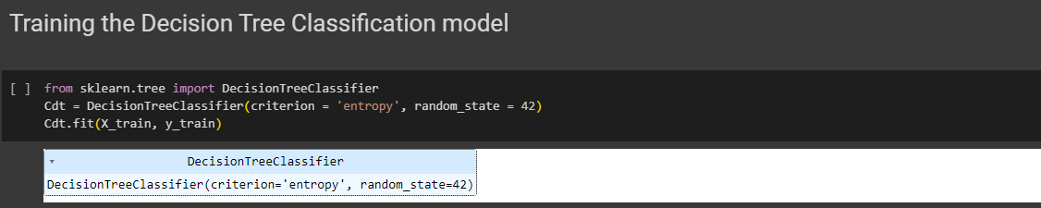

The code utilizes scikit-learn's metrics module to evaluate the performance of a Decision Tree classifier (`Cdt`). It predicts the target variable (`y_pred`) on the test set (`X_test`) using the trained Decision Tree model. The confusion matrix (`cm`) is calculated by comparing the predicted values to the actual values (`y_test`). Additionally, the accuracy score of the model is computed using the `accuracy_score` function, offering an overall measure of model performance.

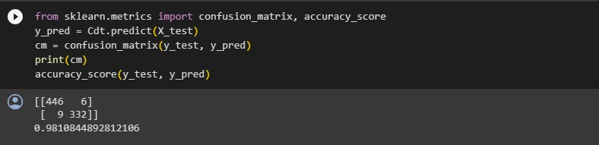

# Applying k-Fold Cross Validation:

The code uses scikit-learn's `cross_val_score` to perform 10-fold cross-validation on a Decision Tree classifier (`Cdt`). It calculates accuracy scores for each fold, and the mean accuracy along with the

standard deviation of the accuracy scores is printed. This provides insights into the Decision Tree model's generalization performance across different subsets of the training data.

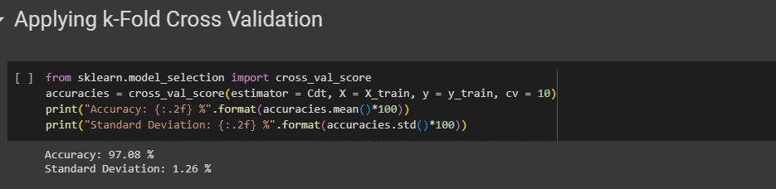

# Training the Random Forest Classification model:

The code uses scikit-learn's `RandomForestClassifier` to instantiate a Random Forest classifier (`Crs`). The classifier is configured with 100 estimators, the entropy criterion, and a specified random state for

reproducibility. It is then trained on the training sets (`X_train` and `y_train`) using the `fit` method, establishing the Random Forest model for subsequent predictions based on the training data.

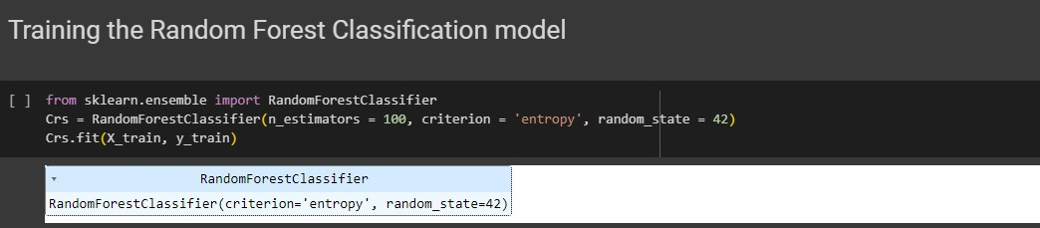

The code uses scikit-learn's metrics module to evaluate the performance of a Random Forest classifier (`Crs`). It predicts the target variable (`y_pred`) on the test set (`X_test`) using the trained Random Forest model. The confusion matrix (`cm`) is calculated by comparing the predicted values to the actual values (`y_test`). Additionally, the accuracy score of the model is computed using the `accuracy_score` function, providing an overall measure of model performance.

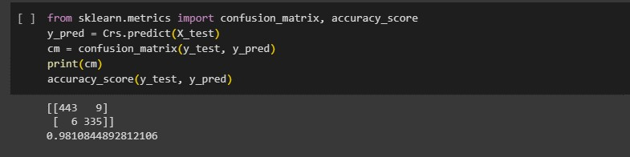

# Applying k-Fold Cross Validation:

The code utilizes scikit-learn's `cross_val_score` to perform 10-fold cross-validation on a Random Forest classifier (`Crs`). It calculates accuracy scores for each fold, and the mean accuracy along with the standard deviation of the accuracy scores is printed. This provides insights into the Random Forest model's generalization performance across different subsets of the training data.

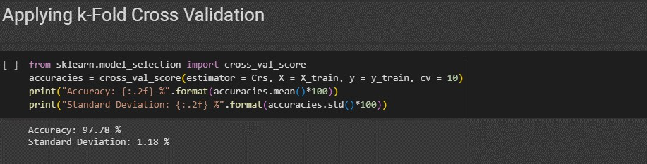

# Training the XGBoost Model:

The code uses the XGBoost library to instantiate an XGBoost classifier (`Cxgb`). The classifier is then

trained on the training sets (`X_train` and `y_train`) using the `fit` method. This establishes the XGBoost model for subsequent predictions based on the training data. XGBoost is a powerful gradient boosting algorithm known for its efficiency and performance.

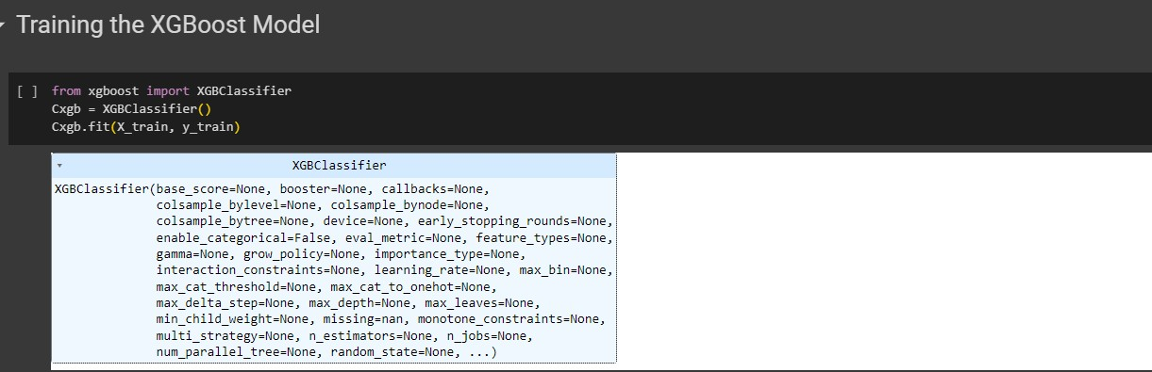

The code utilizes scikit-learn's metrics module to evaluate the performance of an XGBoost classifier (`Cxgb`). It predicts the target variable (`y_pred`) on the test set (`X_test`) using the trained XGBoost model. The confusion matrix (`cm`) is calculated by comparing the predicted values to the actual values (`y_test`). Additionally, the accuracy score of the model is computed using the `accuracy_score` function, providing an overall measure of model performance. XGBoost is recognized for its effectiveness in various machine learning tasks.

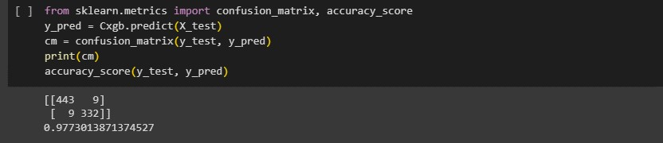

# Applying k-Fold Cross Validation:

The code uses scikit-learn's `cross_val_score` to perform 10-fold cross-validation on an XGBoost classifier (`Cxgb`). It calculates accuracy scores for each fold, and the mean accuracy along with the standard

deviation of the accuracy scores is printed. This provides insights into the XGBoost model's generalization performance across different subsets of the training data.

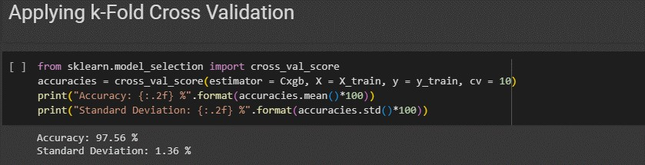

The code uses the `pickle` library to save the trained XGBoost classifier (`Cxgb`) as a binary file named 'fraud.pkl'. This allows for later retrieval and reuse of the model without needing to retrain it. The 'wb' mode indicates writing in binary mode.

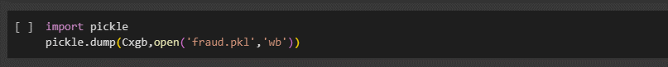

Flask integration:

import numpy as np

from flask import Flask, request, render_template import pickle

app = Flask( name )

model = pickle.load(open('fraud.pkl', 'rb')) @app.route('/')

def home():

return render_template('home.html') @app.route('/predict')

def home1():

return render_template('predict.html') @app.route('/pred', methods=['POST', 'GET']) def predict():

int_features = [float(x) for x in request.form.values()] final_features = [np.array(int_features)]

prediction = model.predict(final_features)

if prediction == 0:

return render_template('predict.html',

prediction_text='Low chances of transaction being

fraud'.format(

prediction),

)

else:

return render_template('predict.html',

prediction_text='High chances of transaction being

fraud'.format(

prediction),

)

if name == " main ": app.run(debug=False, host='0.0.0.0')

**PERFORMANCE TESTING**

**8.1 Performance Metrics**

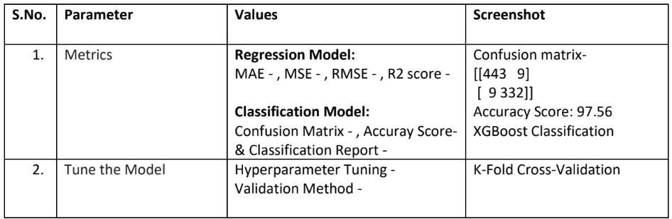

**RESULTS**

**9.1 Output Screenshots**

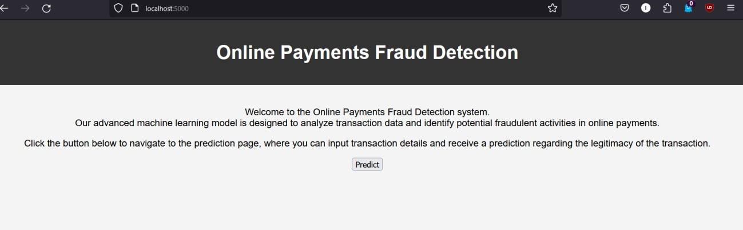

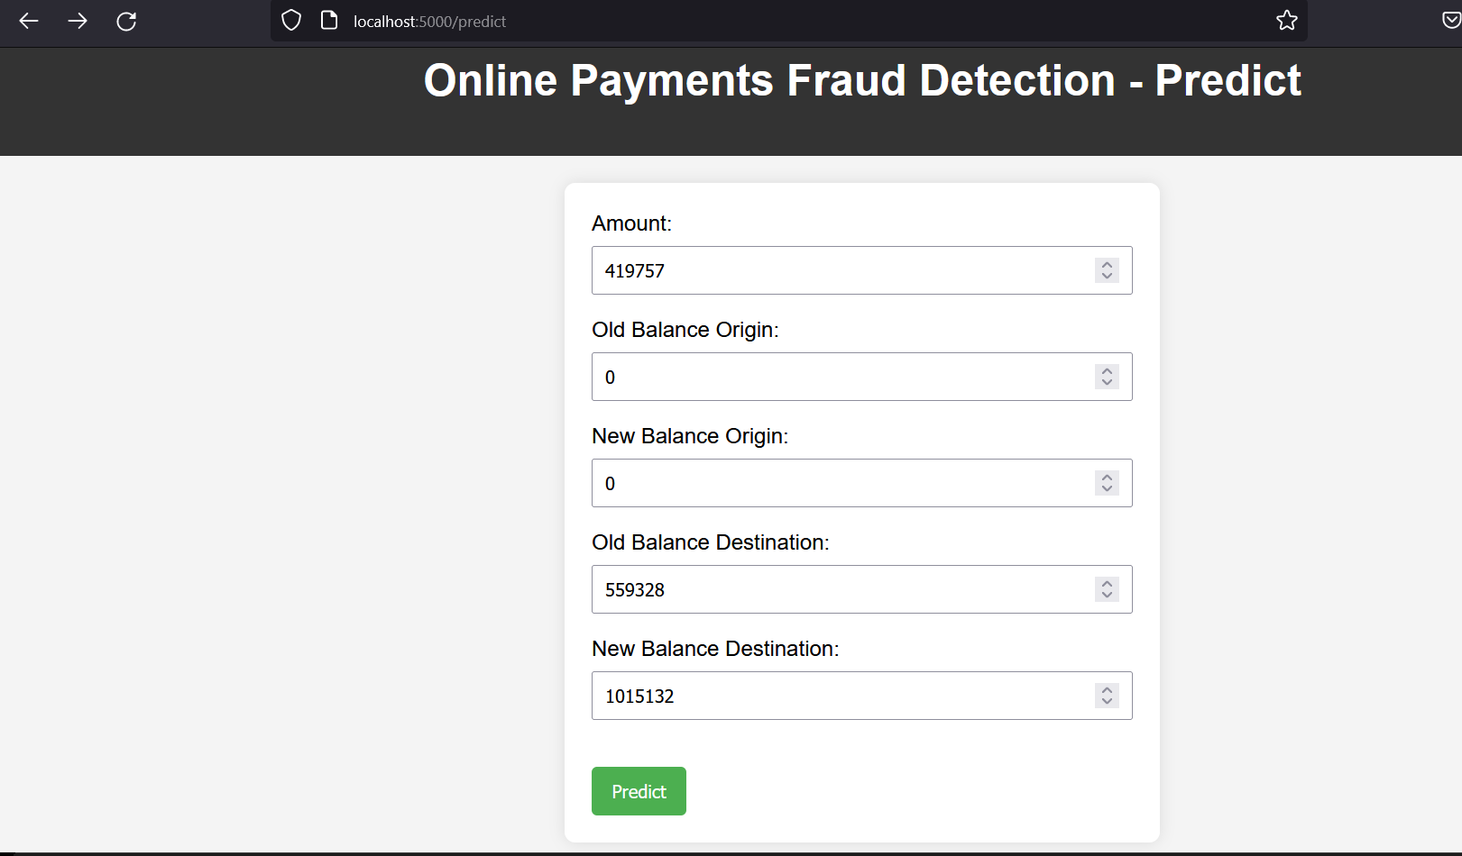



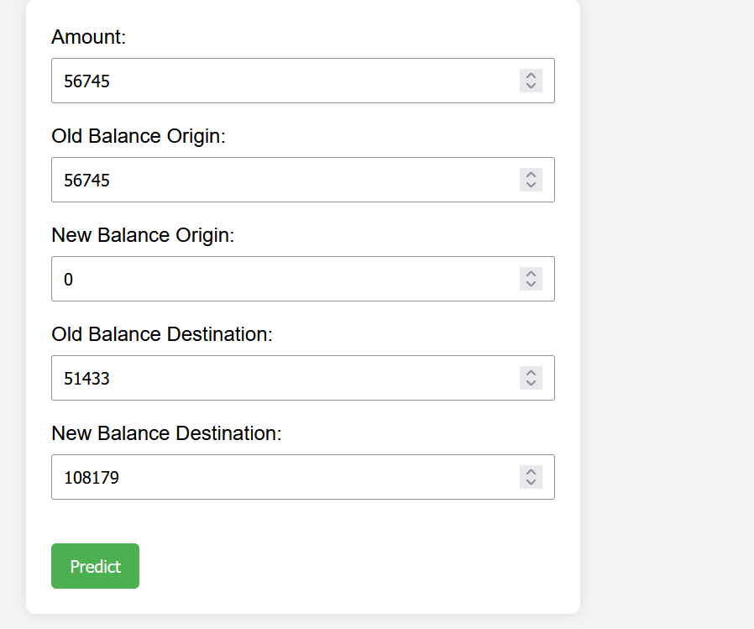



**ADVANTAGES AND DISADVANTAGES**

Advantages:

1. Improved Security:

* The primary advantage is enhanced security for online transactions, reducing the risk of financial losses due to fraudulent activities.

2. Real-Time Detection:

* The system operates in real-time, swiftly identifying and responding to potentially fraudulent transactions as they occur.

3. Adaptability:

* The classification model can adapt and learn from new patterns, improving its effectiveness over time in response to evolving fraud tactics.

4. User Confidence:

* Users can have increased confidence in the online payment system, knowing that there's an active and intelligent fraud detection mechanism in place.

5. Cost Savings:

* Proactive fraud prevention can lead to cost savings by preventing financial losses and the need for extensive post-fraud investigation and recovery efforts.

6. Data-Driven Insights:

* The system generates valuable data and insights into transaction patterns, which can be used for further analysis and improvement of the fraud detection model.

Disadvantages:

1. False Positives:

* A major challenge is the potential for false positives, where legitimate transactions are incorrectly flagged as fraudulent, leading to inconvenience for users.

2. Model Training Complexity:

* Developing an effective classification model requires a good understanding of the dataset and careful tuning, which can be complex and time-consuming.

3. Data Privacy Concerns:

* Handling sensitive financial data raises concerns about data privacy and security, requiring robust measures to protect user information.

4. System Complexity:

* Integrating a real-time fraud detection system into an online payment platform can introduce complexity, requiring careful system architecture and maintenance.

5. Resource Intensive:

* Continuous monitoring and analysis of transactions in real-time may demand significant computational resources, potentially impacting system performance.

6. Evolution of Fraud Tactics:

* Fraudsters are constantly evolving their tactics, and the system needs to continuously adapt to new patterns, making it an ongoing challenge to stay ahead.

7. Dependency on Quality of Training Data:

* The effectiveness of the model depends heavily on the quality and representativeness of the training data. Biased or incomplete data may lead to suboptimal results.

**CONCLUSION**

In conclusion, the development of an online payment fraud detection system presents a compelling solution to the escalating challenges posed by fraudulent activities in digital transactions. By leveraging advanced classification models trained on comprehensive datasets, the project aims to fortify the security of online payment platforms. The advantages of such a system, including improved security, real-time detection, and adaptability, promise a robust defense against evolving fraud tactics.

However, it's essential to acknowledge the potential drawbacks, such as the risk of false positives, model training complexity, and resource-intensive nature. Mitigating these challenges through meticulous model tuning, effective data privacy measures, and a user-friendly interface will be critical to the success and acceptance of the system.

The project not only addresses the immediate need for secure online transactions but also contributes to the broader landscape of digital security. Continuous monitoring, adaptation to emerging fraud patterns, and collaboration with industry best practices will ensure the longevity and effectiveness of the fraud detection system.

In essence, the online payment fraud detection project stands as a testament to the commitment to creating a safer digital environment for users, instilling confidence in online financial transactions, and proactively combating the ever-evolving landscape of cyber threats. As you move forward, the success of the project will undoubtedly hinge on the careful balance of advantages and disadvantages, coupled with a commitment to ongoing improvement and adaptation.

**FUTURE SCOPE**

The future scope of the online payment fraud detection project is promising and extends beyond its initial implementation. Here are some avenues for future development and expansion:

1. Advanced Machine Learning Techniques:

* Explore and incorporate state-of-the-art machine learning techniques, such as deep learning and ensemble methods, to further enhance the accuracy and adaptability of the fraud detection model.

2. Behavioral Analysis:

* Integrate behavioral analysis into the fraud detection system, leveraging user behavior patterns and anomaly detection to identify potentially fraudulent activities that may not be captured by traditional models.

3. Blockchain Integration:

* Investigate the integration of blockchain technology to enhance the security and transparency of online transactions, providing an immutable ledger that can aid in fraud prevention.

4. Collaborative Threat Intelligence:

* Establish collaborations with industry stakeholders, financial institutions, and cybersecurity experts to share threat intelligence and stay ahead of emerging fraud tactics.

5. Continuous Model Training:

* Implement mechanisms for continuous model training and updating to ensure that the system remains effective in identifying new and evolving patterns of fraud.

6. Explainable AI:

* Enhance the interpretability of the classification model to provide clearer insights into the factors contributing to the classification of a transaction as fraudulent, fostering better understanding and trust in the system.

7. Cross-Platform Integration:

* Extend the fraud detection system to integrate with various online platforms and payment gateways, creating a more comprehensive and widespread defense against online payment fraud.

8. Global Compliance Standards:

* Stay abreast of evolving global compliance standards and regulations related to online payments and data protection, ensuring that the system remains in compliance with legal requirements.

9. User Education and Awareness:

* Develop educational initiatives and awareness campaigns to educate users about online security best practices, reducing the likelihood of falling victim to social engineering and phishing attacks.

10. Mobile and IoT Security:

* Address the security challenges posed by the increasing use of mobile devices and IoT (Internet of Things) in financial transactions, adapting the fraud detection system to the unique characteristics of these platforms.

By embracing these future directions, the online payment fraud detection system can evolve into a dynamic and adaptive solution, continuously improving its capabilities and staying ahead of the ever-changing landscape of cybersecurity threats in the digital realm.

**APPENDIX**

GIT Repository link: <https://github.com/smartinternz02/SI-GuidedProject-589203-1697040548>